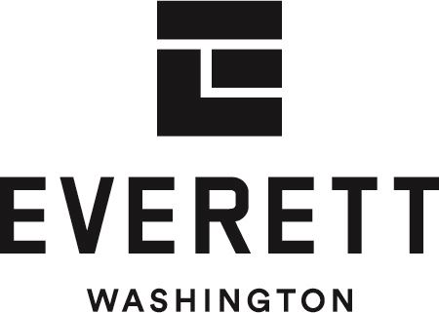 | PROCUREMENT  Request for Proposal #2025-061

Procurement Professional Point of Contact:
Theresa Bauccio-Teschlog, MBA, NIGP-CPP, CPPB
Procurement Specialist
(425) 257-8901
bids@everettwa.gov
2025 General RFP for Parks Partnership

TIMELINE - The following represents the schedule for this solicitation.
Event | Date
Issue Date | September 24, 2025
Site Visit Requests to view sites must be made to the Procurement Professional listed above by Wednesday, October 8th. | October 13, 2025, 9:00 A.M – 12:00 P.M  A schedule will be publicly posted on Thursday prior to the visit as an invitation for others to attend.
Site Visit Requests to view sites must be made to the Procurement Professional listed above by Friday, October 31st. | November 4, 2025, 1:00 P.M. – 3:30 P.M.  A schedule will be publicly posted on Monday prior to the visit as an invitation for others to attend.
Deadline for Final Questions | November 17, 2025, at 11:59 P.M. Pacific Time
Proposal Due Date | December 9, 2025, at 2:00 P.M. Pacific Time
Anticipated Award | Varies depending on the project.
Anticipated Contract Start Date | Varies depending on the project.
Anticipated Contract Term | Contract length will be negotiated based on the proposal and offer.
Submit Sealed Proposals to:
City Clerk’s Office – Attention: Procurement
2930 Wetmore Avenue, Suite 1A
Everett, WA 98201
Clearly label the outside of the sealed envelope containing the original proposal response plus 3 complete identical copies with the Proposal Name, Proposal Number, and contact information listed above. Only Proposals that arrive in the Clerk’s office by the deadline will be considered.
The Clerk’s office is open Monday through Thursday from 8:00 a.m. to 12:00 p.m. and 1:00 p.m. to 5:00 p.m.
Information & Addenda: All Information, including Addenda regarding this solicitation, can be found at:
https://www.everettwa.gov/2713/Bid-opportunities
Suppliers are responsible for checking the City of Everett website for the issuance of any addenda prior to submitting a proposal.
Questions: All questions must be requested electronically utilizing the above link or emailed to the Procurement Professional listed above.
Unauthorized contact regarding this Request for Proposal with City of Everett employees or contractors may result in disqualification. Any oral communications will be considered unofficial and non-binding on the City of Everett. Proposers should rely only on written statements issued by the individual named listed above.

Table of Contents
ANTICIPATED CONTRACT TERM 1
1.1 PROPOSAL SUBMITTAL 4
1.2 REQUEST FOR DUE DATE EXTENSION 4
1.3 WITHDRAWAL OF PROPOSALS 4
1.4 SINGLE RESPONSE 4
1.5 MULTIPLE PROPOSALS 4
1.6 EVALUATION AND AWARD 4
1.7 WAIVER OF MINOR ADMINISTRATIVE IRREGULARITIES & REJECTION OF PROPOSALS 4
1.8 EXCLUDED PARTIES 5
1.9 BUSINESS LICENSE 5
1.10 BID PROTEST PROCEDURES 5
1.11 NON-ENDORSEMENT 5
1.12 PUBLIC DISCLOSURE 5
1.13 RESPONSE PROPERTY OF THE CITY OF EVERETT 5
1.14 NO OBLIGATION TO BUY 6
1.15 COST OF PREPARING PROPOSALS 6
1.16 CONTRACT TERMINATION 6
1.17 RECYCLE 6
1.18 COOPERATIVE PURCHASING (NOT APPLICABLE) 6
2.1 INTENT SUMMARY 7
2.2 BACKGROUND 7
2.3 POTENTIAL OPPORTUNITY EXAMPLES 8
2.4 CONTRACT TRANSITION 12
3. 1 GENERAL 13
3.2 SELECTION PROCESS 13
3.3 CONTRACT AWARD AND EXECUTION 13
3.4 EVALUATION CRITERIA 13
3.5 INTERVIEWS 14
4.1 SUBMITTAL REQUIREMENTS 15
4.2 SUGGESTED RESPONSE FORMAT 15

SECTION 1 - Instructions

PROPOSAL SUBMITTAL
The City Clerk’s office must receive the supplier’s proposal in its entirety by 2:00 p.m. Pacific Time. Proposals arriving after the deadline will be returned unopened to their senders. All proposals and accompanying documentation will become the property of the City of Everett and may not be returned.
Proposal pricing must be submitted on the forms provided in this document. To receive consideration for award, the proposal must be completed and signed by an authorized representative of the supplier. Submission of a proposal constitutes acceptance of the procedures, evaluation criteria, and other instructions of this Request for Proposal (RFP).

REQUEST FOR DUE DATE EXTENSION
Suppliers may request an extension of the Proposal Due Date. Suppliers must supply any justification and additional information that will facilitate an evaluation and decision by the City of Everett. Any approved extension will be issued in an addendum.

WITHDRAWAL OF PROPOSALS
Suppliers may withdraw a Proposal that has been submitted at any time up to the due date and time. To accomplish this, a written request signed by an authorized representative of the supplier must be submitted to the Procurement Professional named on the Request for Proposal cover sheet.

SINGLE RESPONSE
A single response to the RFP may be deemed a failure of competition, and in the best interest of the City of Everett, the RFP may be canceled.

MULTIPLE PROPOSALS
Suppliers interested in submitting more than one Proposal may do so long as each Proposal stands alone and independently complies with the instructions, conditions, and specifications of this RFP.

Evaluation AND AWARD
The City of Everett will award the Proposal to the responsive and responsible supplier(s) whose offer best meets the needs of the City or reject any and all Proposals.

Responsive Supplier – A business entity or individual who has submitted a bid or proposal that fully conforms in all material respects to the Invitation for Bids (IFB)/Request for Proposals (RFP) and all of its requirements, including all form and substance.

Responsible Supplier – A business entity or individual who has the financial and technical capacity to perform the requirements of the solicitation and subsequent contract.

WAIVER OF MINOR ADMINISTRATIVE IRREGULARITIES & REJECTION OF PROPOSALS
The City of Everett reserves the right, at its sole discretion, to waive minor administrative irregularities and informalities contained in any proposal submitted and accepted by the City. The City further reserves the right to make awards to the responsible offer whose proposal is determined to be the most advantageous to the City of Everett. The City of Everett reserves the right to reject any and all proposals.

EXCLUDED PARTIES
All suppliers must certify that they are not on the Comptroller General’s list of ineligible contractors nor the list of parties excluded from federal procurement or non-procurement programs. https://www.sam.gov

BUSINESS LICENSE
The successful supplier will be required to possess or be able to obtain a City of Everett Business License and pay City of Everett Business & Occupation (B & O) Tax, when applicable. B & O Tax questions may be directed to the Everett Business Tax Division at (425) 257-8610.

BID PROTEST PROCEDURES
Chapter 3.46 of the Everett Municipal Code (EMC) governs all protests. Protest Procedures are available for review in the Everett Municipal Code 3.46, which can be found at: https://everett.municipal.codes/
The City reserves the right to require strict compliance with all requirements of Chapter 3.46 EMC.

NON-ENDORSEMENT
As a result of the selection of a supplier to provide the commodities described in Section 2 to the City of Everett, the City of Everett is neither endorsing nor suggesting that the supplier's product is the best or only solution. The supplier agrees to make no reference to the City of Everett in any literature, promotional material, brochures, sales presentation, or the like without the express written consent of the City of Everett.

PUBLIC DISCLOSURE
All materials submitted in response to this RFP become the property of the City of Everett. Selection or rejection of a proposal does not affect this.
Pursuant to Chapter 42.56 RCW and other applicable law, all materials (including, for example, proposals and pricing in proposing) submitted under this RFP are public records and will be, unless determined otherwise by the City in the City’s sole discretion consistent with applicable law, available for inspection and copying by the public following contract award. The City has no obligation to withhold from disclosure materials designated as confidential or proprietary. The City has no obligation provide any notices prior to disclosure.
Materials will not be released by the City of Everett prior to contract award in order to protect the integrity of the procurement process unless otherwise required by law.
Proposers by submission of materials in response to this RFP acknowledge and agree that the City will have no obligation to advocate for nondisclosure in any forum and has no liability whatsoever to proposer for the disclosure of any material submitted by proposer in response to this RFP.

RESPONSE PROPERTY OF THE CITY OF EVERETT
All materials submitted in response to this request become the property of the City of Everett. Selection or rejection of a response does not affect this right.

NO OBLIGATION TO BUY
The City of Everett reserves the right to refrain from contracting with any supplier. The release of this RFP does not compel the City of Everett to purchase.

COST OF PREPARING PROPOSALS
The City of Everett is not liable for any costs incurred by suppliers in the preparation and presentation of proposals and demonstrations submitted in response to this RFP.

CONTRACT TERMINATION
In determining any contract award, the City of Everett reserves the right to consider past performance by the suppliers in the City of Everett contracts. If the City of Everett has previously terminated a contract with a supplier for the supplier's default or other non-performance, the City of Everett reserves the right to reject bids or quotes received from that supplier.

RECYCLE
The City of Everett is committed to the environment and encourages suppliers to recycle materials to the extent practicable.

COOPERATIVE PURCHASING (NOT APPLICABLE)

SECTION 2 – SCOPE OF WORK

INTENT SUMMARY
This Request for Proposals (RFP) process provides an avenue for suggestions that could result in partnerships that will increase recreation opportunities for the public, repurpose or recondition park assets for community use, and generate revenue for the City of Everett Parks & Facilities department. Depending on the complexity of the project, the expected contract start date for these RFPs would be sometime in 2026 - 2027.
This Request for Proposal provides an opportunity for non-profits, businesses, or private individuals to partner with the city to improve the community. The City intends to award multiple contracts from proposals submitted in response to this solicitation. Although project ideas are listed below, Everett Parks is open to all ideas for any Parks-owned property, including different or enhanced services where service currently exists. Do not limit your imagination to only the projects listed below. These ideas are just a small sampling of underutilized park assets owned by the City of Everett that could be great locations for your business.
This is a recurring proposal opportunity, the sixth solicitation in as many years. To score well, projects must enhance Park assets or increase recreational opportunities within the community. Proposals will score higher if they also generate revenue for the department.

BACKGROUND
The City of Everett Parks & Facilities Department has forty-five (45) park properties, two (2) Municipal Golf Courses, an Animal Shelter, a Senior Center, a Swim Center, facility rental halls, athletic sports complexes at Kasch Park, Phil Johnson Park, Senator Henry M. Jackson Park, Garfield Park, and American Legion Park. The Department also contracts for the management of the Legion Memorial and Walter Hall Golf Courses, the Carl Gipson Center, and the Everett Performing Arts Center. The City of Everett’s population and park systems have continued to grow, and now more than ever, it is important to create a vision for the future of Parks and Recreation within our City.
During the previous General RFP processes, the City accepted the following projects and is moving forward with negotiations on 10 of the 21 responses that were received. Some projects that are being negotiated or have resulted in contracts from a previous Request for Proposal process include:
• Management of the Legion Memorial and Walter Hall golf course pro shop and food & beverage operations.
• Concession Agreement for Phil Johnson ballfields.
• Use of the Camp Patterson site at Silver Lake for day camps.
• Adult softball leagues at Kasch Park.
• Paddleboard rentals at Silver Lake which are no longer active.
• Management of the Carl Gipson Center.
• Lease of the greenhouses at Legion Park, which are no longer active.
• Lease of the Kasch Athletic Offices.
• Outdoor Preschool at Howarth Park
• Kayak rentals at Thornton A. Sullivan Park
Several building assets within Everett Parks are underutilized, as well as open spaces where recreation and community access could be created. The general RFP process is open for all ideas and proposals for any City of Everett parkland or park building assets. Some examples of park locations that could be utilized for your business and that the Parks department is especially interested in receiving proposals for include:
• Forest Park Swim Center, 802 E. Mukilteo Boulevard.
• Animal Farm Area, Forest Park, 802 E. Mukilteo Boulevard.
• Forest Park Preschool, 802 E. Mukilteo Boulevard.
• Legion Park Greenhouses 145 Alverson Boulevard.
• Legion Park Horticulture Office, 145 Alverson Boulevard.
• Legion Memorial & Walter Hall Golf Course Restaurant Areas.
• Cemex Property north of Phil Johnson Ballfields, 400 Sievers Duecy Boulevard.
• Senator Henry M. Jackson Park and Ballfields, 3302 18th Street.
• Other ideas include golf driving ranges, BMX tracks, skating venues, and dedicated covered pickleball courts.
The City’s Park patrons include families, youth and adult sports organizations, dog enthusiasts, senior citizens, joggers, walkers, boaters, bicyclists, sports lovers, gardeners, boaters, and outdoor enthusiasts of all ages.

potential opportunity examples
It is important that the proposals that are received accurately reflect the growing needs of the City’s residents and visitors and that the outcomes are rich in community benefit, provide revenue to the department, or greatly improve a park asset. A list of the developed park properties is listed in Appendix A, and proposals can be received for any Everett Park property.
The City is seeking proposals for the development and operation of facilities incorporating enhanced recreational amenities in parks, such as non-traditional, adventure, or extreme sports like BMX, skate parks, throwing venues, paintball, zip line, disc golf, and pump tracks at one or more Everett Parks properties. Additionally, the city is interested in improvements made to existing facilities in exchange for use, such as turf multiuse fields, rental operations, long and short-term rentals, leases, revenue share opportunities, or management agreements for existing facilities. Finally, the city is seeking proposals for the development and operation of year around or seasonal full-service restaurants, gift shops, dance studios, martial arts, or other businesses interested in partnering with Parks to either rent, lease, or share revenue with the City and offer convenience and fun for residents utilizing the Parks. Proposals should follow the format listed in Section 4, which requests an outline of the general idea and location of what is being proposed, including the benefits to the city, City residents, and visitors. If a proposal advances, formal discussions will take place with the potential for contract negotiations. Any modifications to City property are subject to the state prevailing wage rates.
Example Park properties include, but are not limited to:
- Forest Park Area:
- Forest Park Swim Center, 16,390 sf. Photos in Appendix B, Item 1. The structure includes a large natatorium, lobby entry, locker rooms, staff office, main pool, spa, family changing rooms, sauna, separate mechanical rooms for main pool and spa, mechanical mezzanine above locker rooms, large outside concrete sun deck, and modest outside children's wading pool. This pool facility has been incrementally modernized since construction in 1976 but has been dormant for the past 5 years. During the last 5 years that the pool was open (2015-2020), the following projects took place:
- Natatorium lighting, exhaust fan motor, and ceiling fan replaced.
- Replaced circulation pumps, flow meter, and chlorine feed to indoor and outdoor pools.
- Replaced main boilers and hot water boilers and installed tankless units in locker rooms.
- Replaced MCC and control system.
- Upgraded electrical distribution system for the main pump room and spa.
- Replaced chiller supply pump.
- Added new heat exchanger supply pump.
- Rebuild the Sauna interior and controls.
- Replaced sump pump drain.
- Replaced heating and cooling elements of the HVAC system.

- Forest Park Swim Center Building – Non-Pool Uses. Everett Parks is open to proposals for the Forest Park Swim Center building that does not include pool use. Some ideas that emerged from the 2023 Swim Center Feasibility Study include:
- Converting a portion of the indoor and outdoor space into an Early Learning Center and play area. Photo in Appendix B, Item 1.
- Converting the indoor and outdoor space into a skate park. Photo in Appendix B, Item 1.
- Converting the indoor space into recreational courts. Photo in Appendix B, Item 1.
- Other ideas that were part of the study but that do not have drawings included are:
  - Conversion to Private Lease space
  - Event Center
  - High Ropes Course
  - Bouldering or Rock Climbing
  - BMX Biking and Pump Track
  - Yoga & Group Fitness Center
  - General Fitness Uses

- Animal Farm in Forest Park, 802 E. Mukilteo Blvd. The area comprises 8 buildings on the west side of Forest Park. Photos in Appendix B, Item 2.
- The Animal Farm Program spaces and sizes are described below:
- Classroom – 720 SF
- Bunny Bank – 80 sf
- Bunny Barn – 200 sf
- Duck Building – 200 sf
- Horse Barn – 1,100 sf
- Main Barn and Office – 828 sf
- Pig Building – 150 sf
- Poultry Building – 350 sf
- Animal Farm - Everett Parks is open to proposals and opportunities to convert the existing Animal Farm space for another non-farm use as well.

- Fieldhouse is currently set up as a preschool classroom in Forest Park, 802 E. Mukilteo Blvd., 1500 SF. This site includes a classroom or meeting space, restroom, and kitchenette with refrigerator, microwave, sink, and storage. A successful non-licensed preschool has been running out of this location for several years. The city would like to find a partner to run their own preschool business out of this location, which would result in the city earning rent or profit sharing. Photos are provided in Appendix B, Item 3.

- Lion’s Hall is currently used as a rental hall in Forest Park, 802 E. Mukilteo Blvd., 1,800 SF. This site includes new vinyl laminate floors that could be used as a classroom or meeting space, two (2) restrooms, and a kitchenette with refrigerator, stove, sink, and storage. Photos in Appendix B, Item 4.

- Spruce Hall has been used for short meetings in Forest Park, 802 E. Mukilteo Blvd., 768 SF. This is a room with hardwood floors and no restroom, although Forest Park restrooms are within walking distance. Photos in Appendix B, Item 5.

- Concession Opportunity, in Forest Park, near Recreation Office and horseshoe area, 802 E. Mukilteo Blvd. Photos in Appendix B, Item 6.
- Location Description: asphalt pad by parking lot.
- Amenities: electricity and water.
- Demographics: children, parents, park users, special event participants.
- Peak Season: May through September.
  - Potential offerings: kettle corn, ice cream, snacks, drinks, espresso.

    - Concession Opportunity, in Forest Park, near Floral Hall and the Forest Park Swim Center, 802 E. Mukilteo Blvd. Photos in Appendix A, Item 7.
- Location Description: asphalt pad.
- Amenities: prime location for mobile vendors for parties and events.
- Demographics: children, parents, park users, special event participants.
- Peak Season: May through September.
- Off-Peak Season: October through April.
- Potential offerings: food truck-style concessions.

- American Legion Park Area:

    - Legion Park Horticulture Office and Greenhouse Area, 145 Alverson Blvd. The gravel area at the south side of Legion Park has historically been used as park maintenance offices and the hub of horticulture activities in Everett. Everett eliminated the annual flower program in 2020, leaving the greenhouses and offices available for rental or lease by an interested organization. The city is interested in receiving responses for all or part of the buildings listed below. Photos in Appendix B, Item 8. Access through the property by the Legion Memorial Golf staff would be required.
- Horticulture Offices – 2600 sf
- Horticulture Classroom – 1600 sf
- Greenhouse 3 – 1400 SF
- Greenhouse A – 1000 SF
- Greenhouse B – 1400 SF

- Cemex Property North of Phil Johnson Ballfields:

  - The Cemex Property is located just north of the Phil Johnson Ballfields, 400 Sievers Duecy Blvd. Photos in Appendix B, Item 9. Proposals for this location must have capital to invest in their project. Partnerships with other organizations to increase recreational opportunities and share costs are highly encouraged. There will also be a need for permitting, planning, and construction. The City encourages proposals to be submitted that are contingent upon the ability to use the site as desired. Below are just a few ideas:
    - RV Park to serve the needs for tournaments at Phil Johnson ballfields
    - BMX Track
    - Pump Track
    - Skate Park
    - Multi-use fields for Soccer, Lacrosse, Baseball/Softball
    - Any court sports
Once Everett Parks finds a viable partner to invest in recreational opportunities at Cemex, then Parks would likely move forward with a master plan and use Park Impact Fee dollars to add open space and other park amenities on site.

- Senator Henry M. Jackson Park and Ballfields:
- Jackson Park, as it is more commonly referred to, is home to two (2) baseball fields, a community garden, a restroom, and open space looking out over the Snohomish River, 3302 18th St. Photos in Appendix B, Item 10.

- Legion Park & Walter Hall Golf Course Restaurant Areas:
    - Legion Memorial Golf Course Restaurant: The full-service restaurant at Legion Memorial Golf Course has a seating capacity of 162, with banquet seating options and a small private dining area for up to 20 people. Outdoor patio seating can accommodate up to 16 people. Photo in Appendix B, Item 11. Additional amenities include:
- Walk-in refrigerator and freezer
- Hot dog roaster
- Fryer
- Beverage cooler

  - Walter E Hall Golf Course Restaurant: The full-service restaurant at Walter E Hall Golf Course has a seating capacity of 32 in the restaurant and patio seating of up to 16 people. Photos in Appendix B, Item 12. Additional amenities include:
- Walk-in refrigerator and freezer
- Hot dog roaster
- Fryer
- Beverage cooler

- Eclipse Mill Park, scheduled to open in 2028:
- The new 3-acre park at Eclipse Mill along the Snohomish Riverfront is scheduled to open in 2028. It will include amenities such as a parking lot, restroom, open space, and non-motorized boat access. Photos are in Appendix B, Item 13.

CONTRACT TRANSITION
In the event of a follow-on contract award to another supplier, the Proposer shall ensure a cooperative and smooth transition to a new contract provider and shall provide all records, status reports, and contract files as agreed with the provided notice of termination.

SECTION 3 – PROPOSAL EVALUATION PROCESS

3. 1 GENERAL
All proposals will be reviewed to determine compliance with the requirements specified in the RFP. Proposals will be evaluated on how well they meet the city's needs, as described in the supplier’s response to each requirement and the evaluation criteria identified in this RFP. It is important that the responses be clear and complete so that the evaluators can adequately understand all aspects of the proposal.

3.2 SELECTION PROCESS
The City will select the proposal that, in its sole discretion, is the most advantageous to the City. The City reserves the right to make an award without further discussion of the proposal submitted; there may be no best and final offer procedure. Therefore, the proposal should be initially submitted on the most favorable terms that the supplier can offer. The specifications may be altered by the City of Everett based on the supplier’s proposal, and an increase or reduction of services with the supplier may be negotiated before contract signing, award, and execution.

3.3 CONTRACT AWARD AND EXECUTION
A contract award will be for the supplier that best meets the needs of the City of Everett.
The award of a contract to the successful supplier will be the notice of acceptance. The award of a contract will bind the supplier to furnish the service in accordance with the information herein, responses to questions, the supplier’s proposal, other representations made, and all other terms and conditions of the contract in its final form.

3.4 EVALUATION CRITERIA
Proposals will be evaluated based on the following weighted criteria and how well they meet the needs and requirements as described in the RFP.
# | Criteria | Points | Description
1 | Qualifications and Relevant Experience | 50 | Evaluate responses to Questionnaire 4.03.
2 | Technical Capability, Approach, and Capacity | 100 | Evaluate responses to Questionnaire 4.03.
3 | Communication and Recreational Benefit | 100 | Evaluate responses to Questionnaire 4.03.
4 | Risk, Performance, and Quality Assurance | 25 | Evaluate responses to Questionnaire 4.03.
5 | Price Proposal | 225 | Evaluate Suppliers’ price proposals to determine if the cost is fair and reasonable. Proposed prices:  - are realistic for the work to be performed and  - demonstrate that the Supplier understands the Scope of Work.
 | Total | 500

3.5 INTERVIEWS
The City of Everett may request interviews with the highest-ranked Supplier(s). The purpose of the interview, if held, will be to further review the finalist(s) in specific areas to determine which proposal provides the best fit and value to the City of Everett. Finalist(s) must have key employees available for these interviews. The City of Everett will notify the finalist(s) of the time, date, and location for an interview or conference call.

SECTION 4 – PROPOSAL SUBMITTAL REQUIREMENTS

4.1 SUBMITTAL REQUIREMENTS
Suppliers must provide a proposal that must demonstrate an understanding of the project requirements as stated throughout this Request for Proposal.
Proposals in response to this RFP must be submitted in the order specified below. Proposal responses must include:
- Supplier Commitment and Information (included)
- Price Sheet (included)
- Narrative responses to the questions asked. Suppliers should re-type the heading, question identifier, and question. Then, answer the questions and provide in the same order requested below. Suppliers may emphasize in their narrative any areas of their proposal that they believe exceed our requirements.
- Certificate of Non-Debarment/Suspension (included)

4.2 SUGGESTED RESPONSE FORMAT
- Standard 8 1/2" x 11" paper
- Single or double-sided, numbered pages
- Typed with a minimum of 12-point font
- Form 4.03 – re-type the question before responding
Sealed Proposal Submissions must be submitted in a SEALED ENVELOPE using the optional Proposal Opening Label (below) or clearly marked with the Proposal Number and Title to the City of Everett no later than the proposal due date and time.
URGENT – SEALED PROPOSAL ENCLOSED
Do Not Delay – Deliver Immediately
 |  | URGENT | 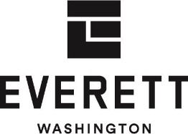 | City Clerk’s Office  Attention: Procurement  2930 Wetmore Ave, Suite 1A  Everett, WA 98201 |  | URGENT
 |  | URGENT | RFP Number: | 2025-061 |  | URGENT
 |  | URGENT | RFP Title: | 2025 General RFP for Parks Partnership |  | URGENT
 |  | URGENT | Procurement Professional: | Theresa Bauccio-Teschlog, MBA, NIGP-CPP, CPPB |  | URGENT
 |  | URGENT | Supplier: |  |  | URGENT
FORM 4.01 SUPPLIER COMMITMENT AND INFORMATION
REQUEST FOR PROPOSAL #2025-061 2025 General RFP For Parks Partnership

 | Company Name:
 | Company Address:
 | City: |  |  |  | State: |  |  | ZIP:
 | Tax ID #: |  |  |  | UBI #:
 | Legal status of supplier organization, i.e., corporation, partnership, sole proprietorship.
 | Diversity Certification (if applicable): ☐ Disadvantaged Business Enterprise (DBE) ☐ Minority Business Enterprise (MBE) ☐ Women Business Enterprise (WBE) ☐ Minority Women Business Enterprise (MWBE) Certification number:
 | Website: |  |  |  | City of Everett Business License #
 | Supplier Contact Name (if different from Authorizing Official): |  |  |  | Supplier Contact Title:
 | Supplier Contact Email: |  |  |  | Supplier Contact Direct Phone:
 | Supplier Contact Address (if different from above):
 | City: |  |  |  | State: |  |  | ZIP:
By responding to this solicitation, the Supplier understands and agrees to be bound by all requirements and contract terms and conditions contained in this solicitation. By signing this form, the Supplier acknowledges receipt and understanding of any and all addenda issued for this solicitation. This form, signed by an individual authorized to legally commit the Supplier, must be submitted as the cover page.
The Supplier also certifies that:
- I am authorized to commit my firm to this Proposal and that the information herein is valid for 300 calendar days from this date.
- That all information presented herein is accurate and complete and that the scope of work can be performed as presented in this proposal upon the City’s request.
- That I have had an opportunity to ask questions regarding this Proposal and that those questions have been answered.
- That this Proposal response is made without prior understanding, agreement, or connection with any corporation, firm, or person submitting an offer for this Proposal and is in all respects fair and without collusion or fraud.
This form may be signed by ink signature, copy of ink signature, copy of signature, e-signature or any other form of signature. By submitting this bid, the bidder agrees that its signature will have the same legal effect as an original ink signature.
 | Authorizing Official Name: |  |  |  | Authorizing Official Title:
 | Authorizing Official Email: |  |  |  | Authorizing Official Phone:
 | Authorizing Official Signature and Date:
FORM 4.02 PRICE SHEET
REQUEST FOR PROPOSAL #2025-061 2025 General RFP For Parks Partnership
Supplier Name:
Prices must include providing all services as detailed in the Scope of Work.
Provide a complete price proposal describing the financial revenue or other financial benefits offered.
- Define the proposed City of Everett Park property location(s).
- In one paragraph, describe the project. What do you hope to do at this location?
- Describe the suggested revenue model, including anticipated or forecasted revenue from your proposal and proposed city compensation.
- Clearly define the proposal's expectations for city funding.
- Include detailed project costs incurred by the proposer to create a turn-key operation, including initial and ongoing costs.
- Describe and include the value of any capital improvements that will be provided at no cost to the city.
- Describe any immediate tenant or asset improvements the city will gain from your project.

FORM 4.03 QUESTIONNAIRE
Suppliers must complete this “Questionnaire,” providing the information in the same order requested below. In their narrative, suppliers may emphasize any areas of their proposal that exceed our requirements.
- Qualifications and Relevant Experience
- Briefly describe your company and any partners. Include how long each company has been in business.
- Describe the qualifications of your company, its business experience, and achievements.
- Describe each organization's previous experience in implementing similar projects or providing services to parks or similar venues.
- Who are you proposing to be the project manager if awarded this contract? What is their experience with this work and other aspects pertinent to this project? What are their years of experience, years in the industry, years with the firm, years of applicable licenses, etc.?
- Technical Capability, Approach, and Capacity
  - What is your approach to this project? What length of contract is needed to make this endeavor worth it for your business? Describe your execution, management, and control of the project. Include a business plan specific to this proposal and a financial proforma that covers the duration of the contract you are proposing.
  - Describe any environmental or sustainability benefits of your proposal. Include sustainable related strategies, practices, services, or products that may reduce the environmental impact.
  - Provide a timeline plan for this project.
  - Describe the proposed customer service plan. This includes, at a minimum, the process of addressing customer comments, complaints, issues, and incidents received via any communication channel. Include the process of keeping the city informed of complaints that are received.
  - Does your firm intend to subcontract any portion of this contract? If so, please provide the following: the name of the firm(s), the percentage of work to be performed by each subcontractor, and a description of the nature of work performed by each.
- Communication and Recreational Benefit
  - Describe how the City of Everett Parks Department, residents, or visitors will benefit from your project. Why should the City accept your proposal in terms of community and recreation benefits? How many people do you anticipate serving annually?
  - Describe how your proposal would benefit Everett’s diverse population, including marginalized, underrepresented, and at-risk communities.
  - Describe any other benefits to the city, residents, and visitors that have not already been addressed.
- Risk, Performance, and Quality Assurance
  - Submit no more than five (5) completed relevant project experiences within the past ten years that demonstrate successful contract performance similar in size and scope as described in this RFP, including any government experience. Include the following for each reference:
    - Company name and full address
    - Point of contact name, title, e-mail address, and phone number
    - Contract title, number, start, and completion dates.
    - Contract description and service details.
B. Disclose any legal action that is in progress or has been taken against the proposing entity or individuals in the last five years.
C. Disclose all business transactions and relations within the last five years that may create or be perceived to create a conflict of interest. Have you defaulted on any contracts within the past three years or failed to meet contract terms? If so, describe.

FORM 4.04 CERTIFICATE OF NON-DEBARMENT/SUSPENSION
REQUEST FOR PROPOSAL #2025-061 2025 General RFP For Parks Partnership

CERTIFICATION REGARDING DEBARMENT, SUSPENSION AND OTHER
INELIGIBILITY AND VOLUNTARY EXCLUSION
LOWER TIER-COVERED TRANSACTIONS

The Lower Tier Participant (Applicant for a third-party subcontract or subgrant under a federal funded project),
hereinafter referred to as Supplier, certifies, by submission of this document, that neither it nor its principals is presently debarred, suspended, proposed for debarment, declared ineligible or voluntarily excluded from participation in this transaction by any federal department or agency.

Where the Supplier is unable to certify to any of the statements in this certification, such Supplier must attach an explanation to this submittal.

The Supplier, , certifies or affirms the truthfulness and accuracy of the contents of the statements submitted on or with this certification and understands that the provisions of 31 U.S.C. Section 3801 et seq. and Title 2 CFR Part 180 are applicable thereto.

Signature of Authorized Official

Title of Authorized Official Date

THIS FORM MUST BE COMPLETED BY THE PRIME SUPPLIER AND ANY SUB-TIER SUPPLIERS THAT WILL BE AFFILIATED WITH THE WORK IN THIS QUOTE. RETURN ALL COMPLETED FORMS WITH ORIGINAL QUOTATION PACKAGE.

SECTION 5 – ACRONYMS & DEFINITIONS
Bidder: see “Supplier”.
CFR: Code of Federal Regulations.
City: refers to the City of Everett (“COE”), located in Washington State.
Code Requirement: all applicable requirements of the City of Everett Municipal Code (EMC) Title 16, along with any applicable codes including, but not limited to, International Mechanical Code, International Plumbing Code, and International Energy Conservation Code. EMC Title 16 can be found here: https://everett.municipal.codes/EMC/16
Contractor: see “Supplier”.
Contract Administrator: see “Procurement Professional”.
Cost Analysis: comparison of offered price to the offeror’s own costs and evaluation of the difference (profit).
Desired Features: features that a requested commodity or solution does not have to possess to be considered responsive. However, inclusion of such features are considered value added qualities that may lead to a higher level of success and evaluation score for the proposal response. These are in addition to the salient characteristics included in the solicitation.
L&I: the Washington State Department of Labor and Industries.
Lower Tier Participant: see “Supplier”.
Mandatory Features: a condition set out in the scope of work or specifications that must be met without alteration. Not meeting a mandatory requirement may be grounds for disqualification of a bid or proposal.
Must: see “Shall”.
Offeror: see “Supplier”.
Price Analysis: comparison of proposed price to comparable pricing data.
Prime Contractor: see “Supplier”.
Procurement Professional: the individual in Procurement assigned by the City of Everett who is responsible for resolving contractual issues and supporting the Project Manager during Contract performance. This includes the issuance of a written document to amend, modify, or deviate from the Contract terms, conditions, requirements, specifications, details, or delivery schedule.
Project Manager: the individual assigned by the requesting department that is responsible for managing, inspecting, and monitoring all Contractor work performed to ensure compliance with the contract requirements. The Project Manager is the Contractor’s primary point of contact and acts as the agency’s representative in charge of work at the site.
Proposer: see “Supplier”.
RCW: Revised Code of Washington.
Recipient: see “City”.
Shall or Must: the terms “shall” or “must” are used whenever a specification expresses a requirement by either the City or the Supplier.
Subcontractor: the individual, association, partnership, firm, company, corporation, or joint venture entering into an agreement with the Supplier to perform any portion of the work covered by this contract.
Submittals: information which is submitted to the City of Everett by the Supplier.
Supplier: the individual, association, partnership, firm, company, corporation, or a combination thereof, including joint ventures, submitting a response to perform the work.
UCC: Uniform Commercial Code.
WAC: Washington Administrative Code.

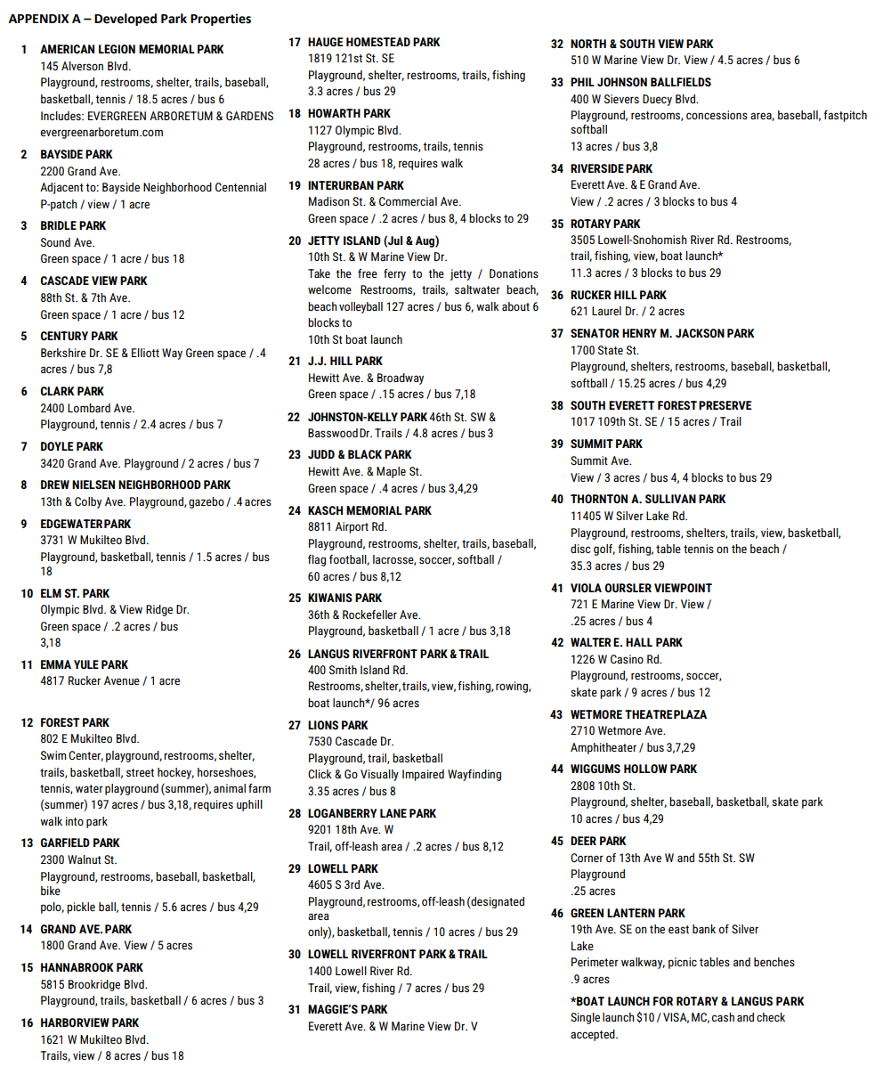
APPENDIX B
Item 1: Forest Park Swim Center – Pool and Non-pool Uses.
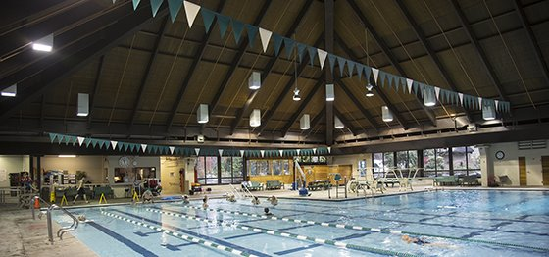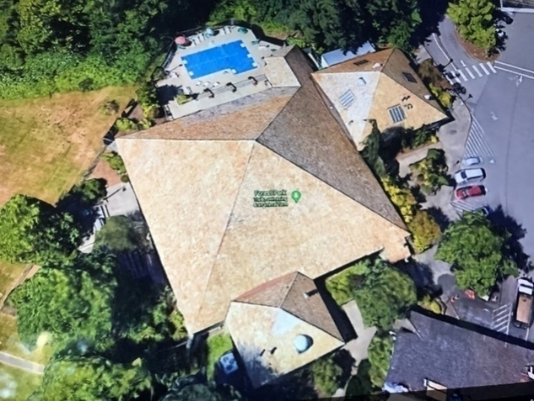

Forest Park Swim Center conversion to Early Childhood Learning Center
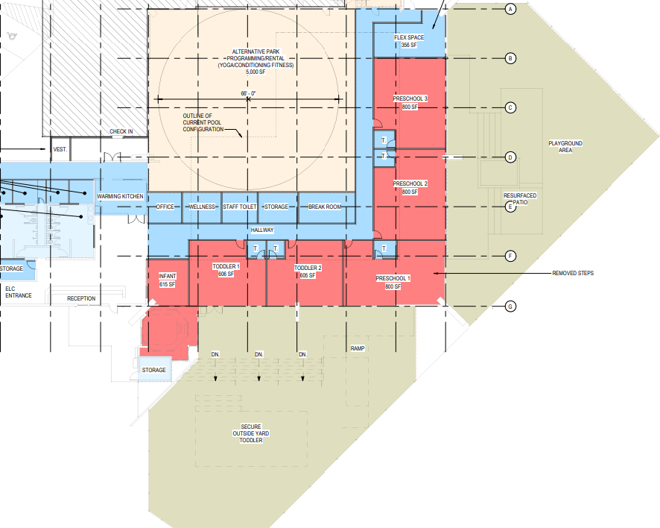
Forest Park Swim Center conversion to Indoor and Outdoor Skate Park
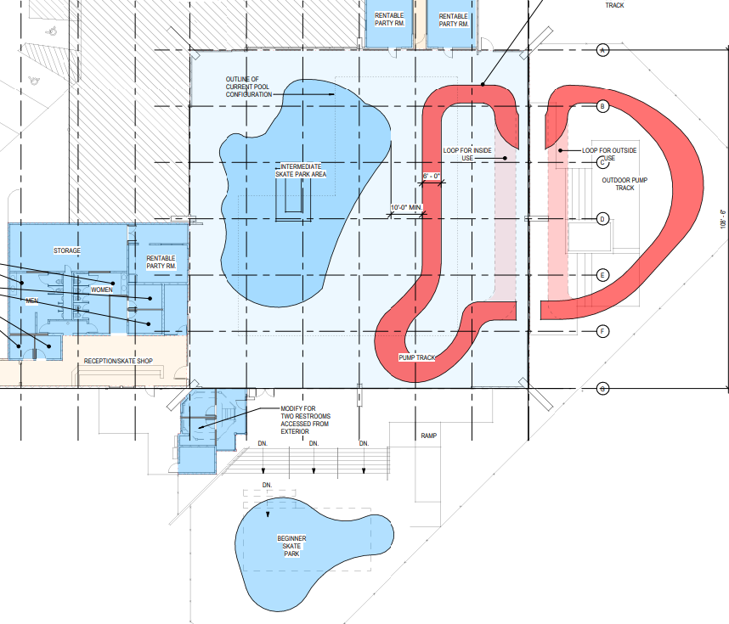

Forest Park Swim Center conversion to Recreational Courts:
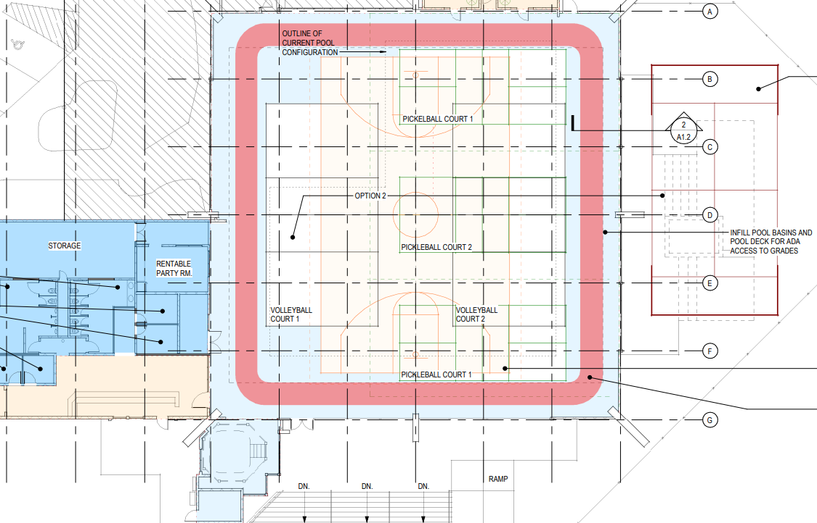

Item 2: Animal Farm at Forest Park
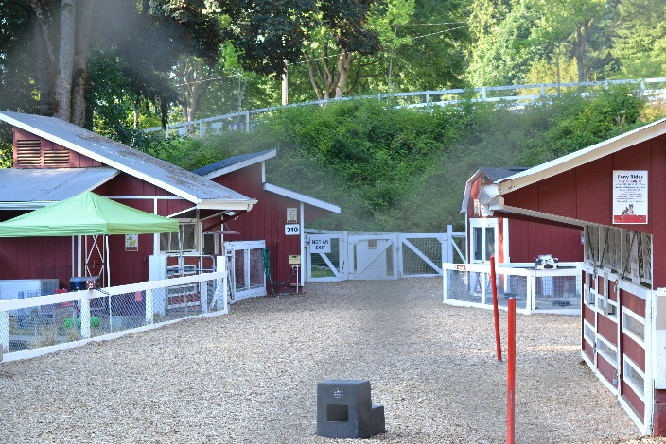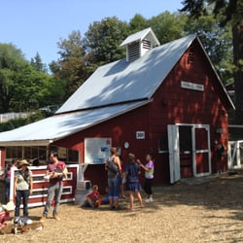
Classroom: Bunny Bank: Horse Barn:
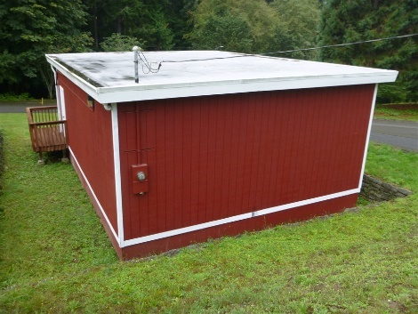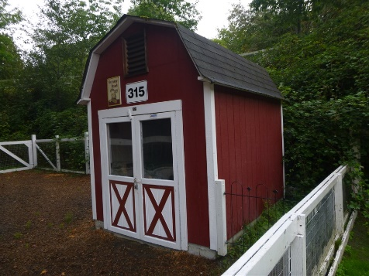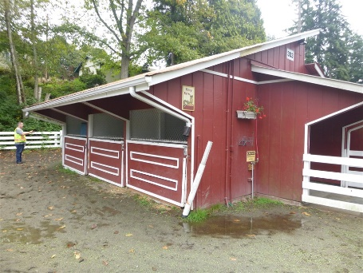
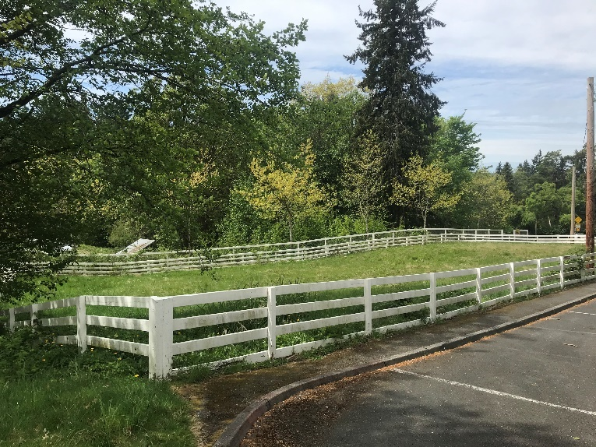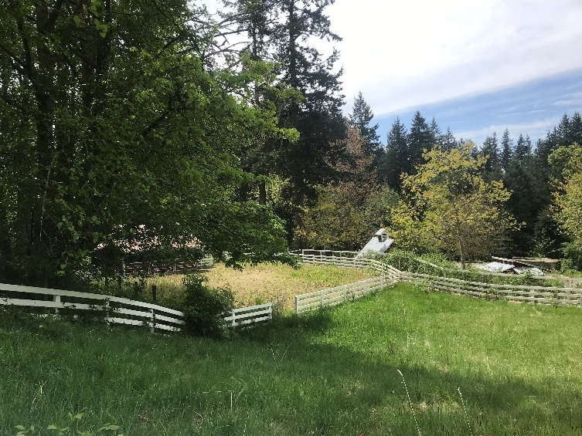

Item 3: Forest Park - Fieldhouse (Preschool)
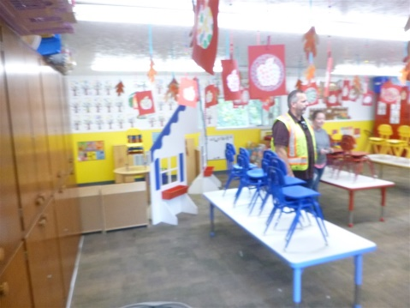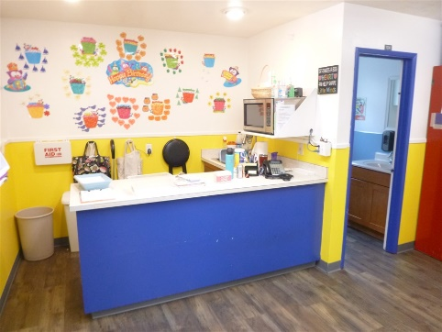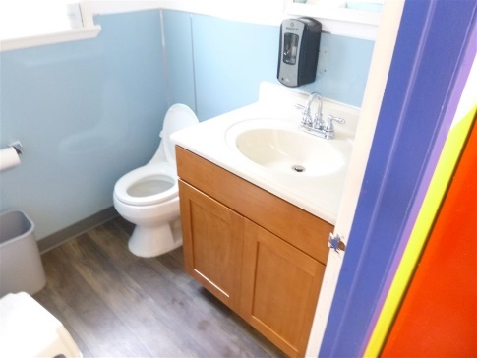
Item 4: Forest Park - Lions Hall
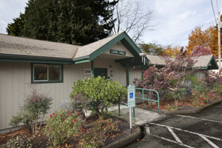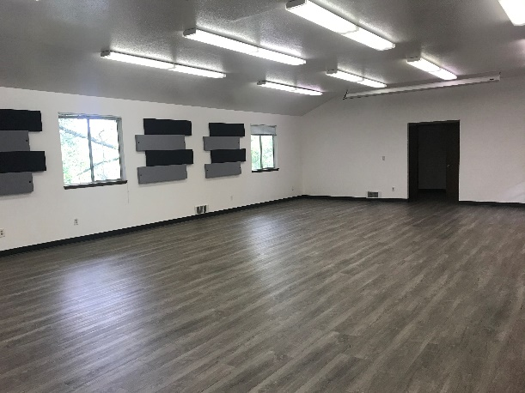
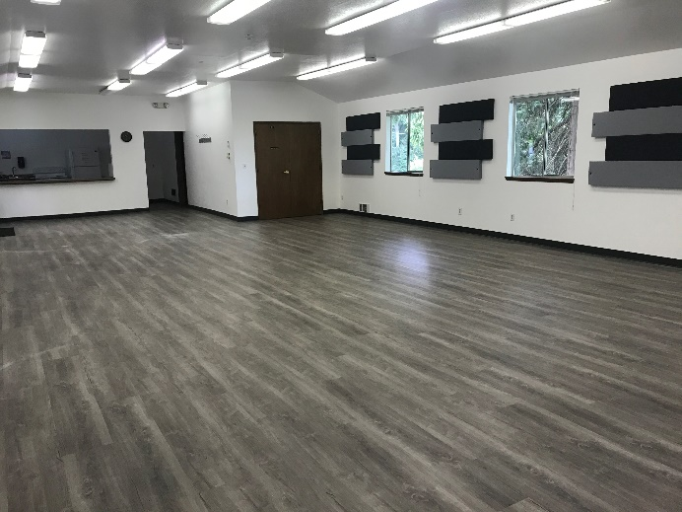

Item 5: Forest Park - Spruce Hall:
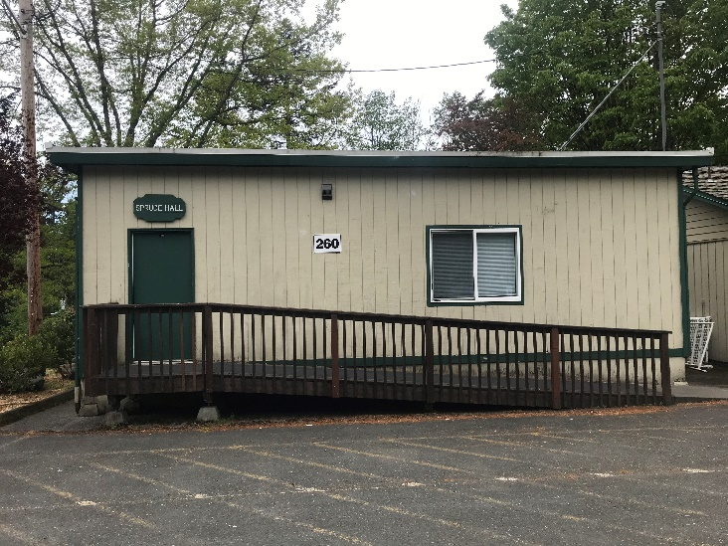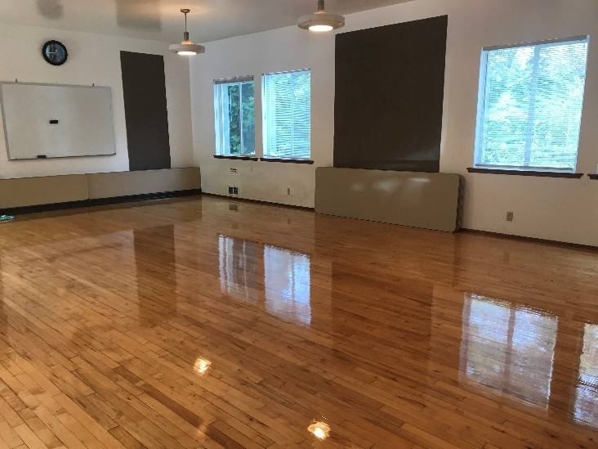
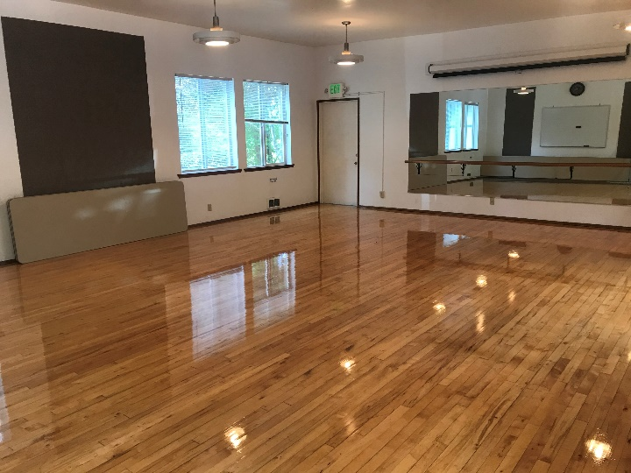
Item 6: Forest Park - Concession Site, Concrete Pad:
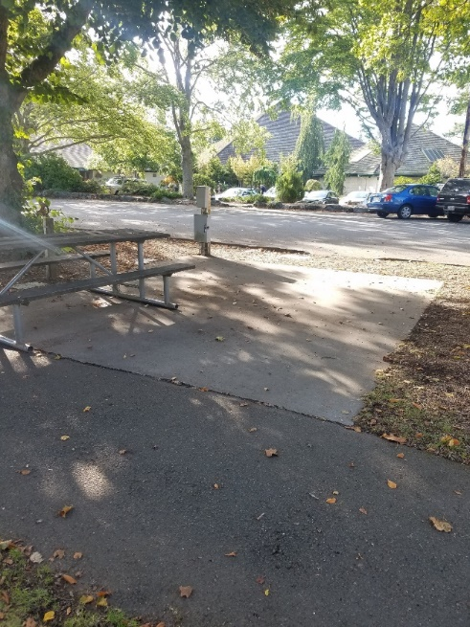
Item 7: Forest Park – Concession Site, between Floral Hall and Swim Center:
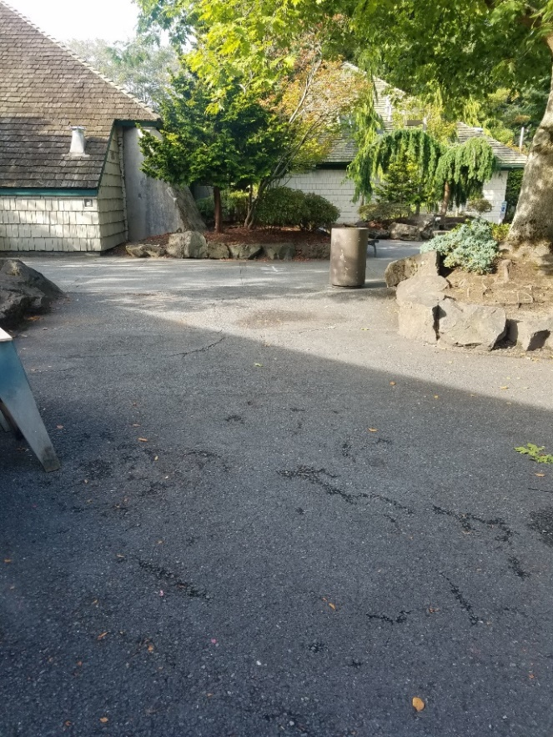

Item 8: Legion Park - Horticulture Area
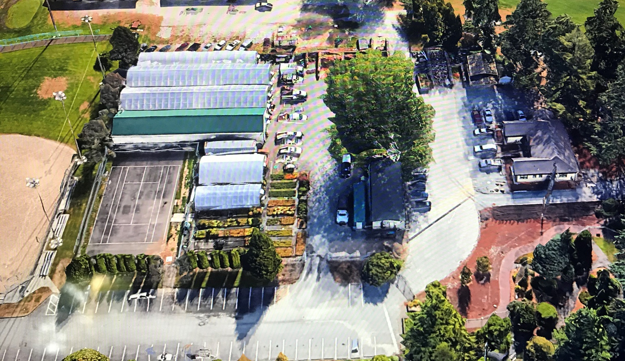
Legion Horticulture Office:
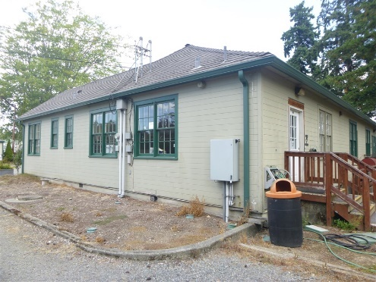

Item 9: Former Cemex Property on Sievers Duecy Road
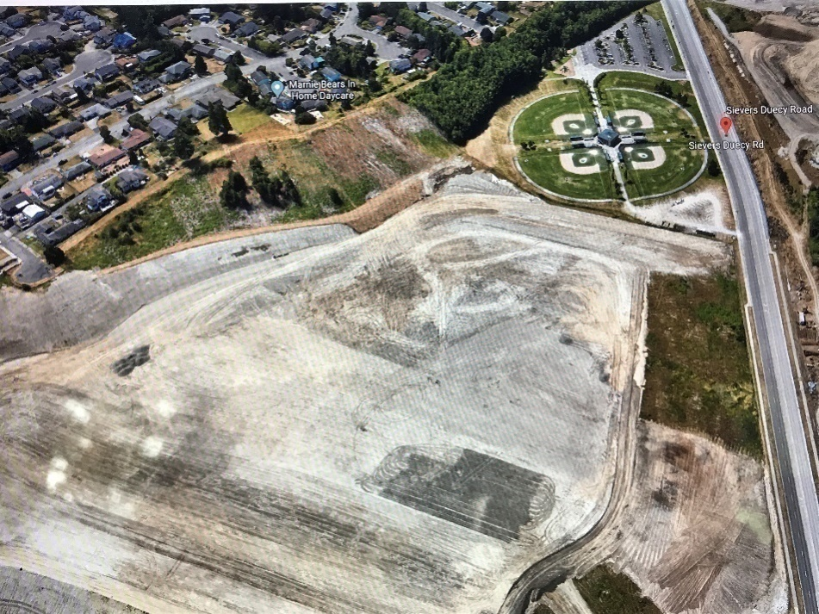
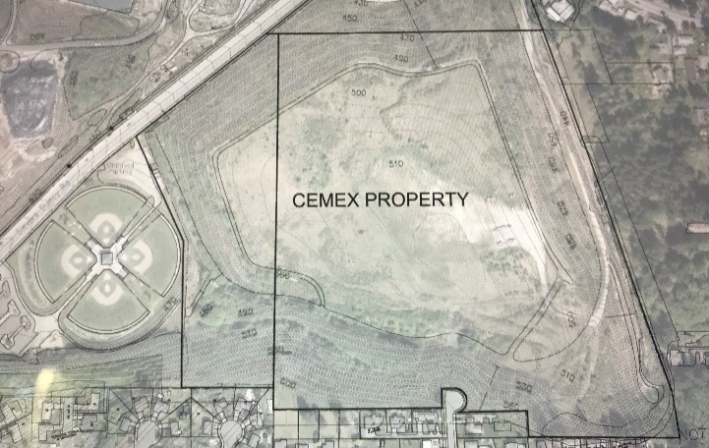
Item 10: Senator Henry M. Jackson Ballfields (Qty 2)
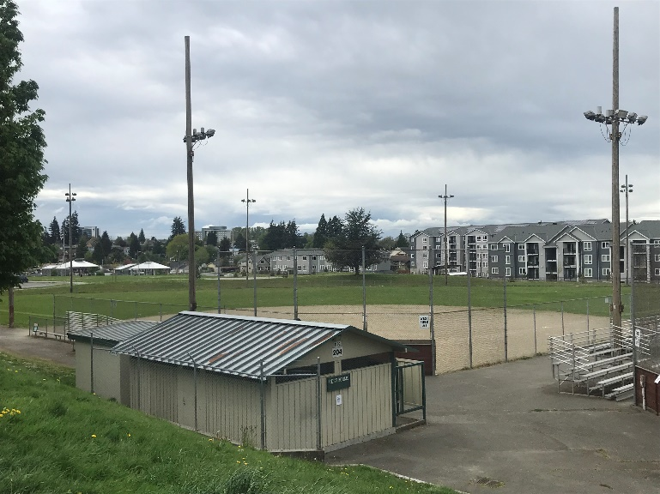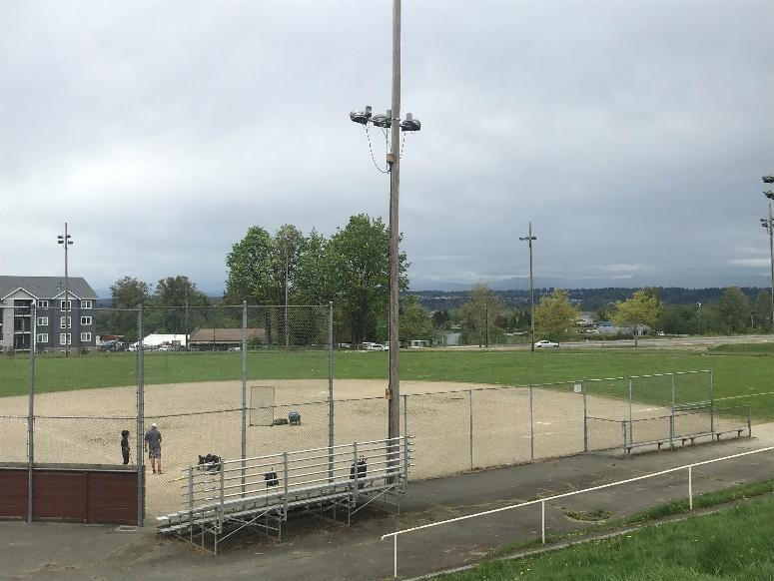
Item 11 Legion Golf Course Restaurant
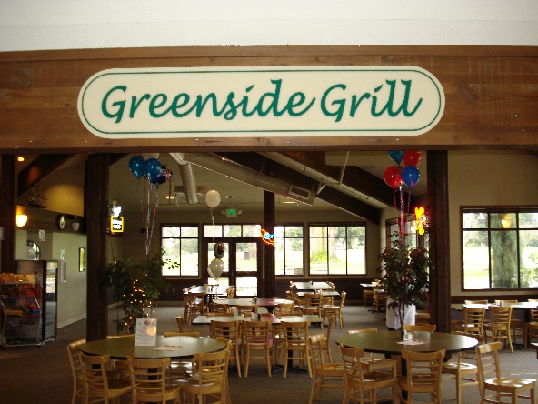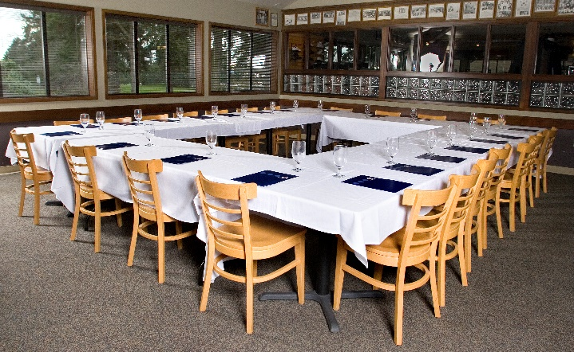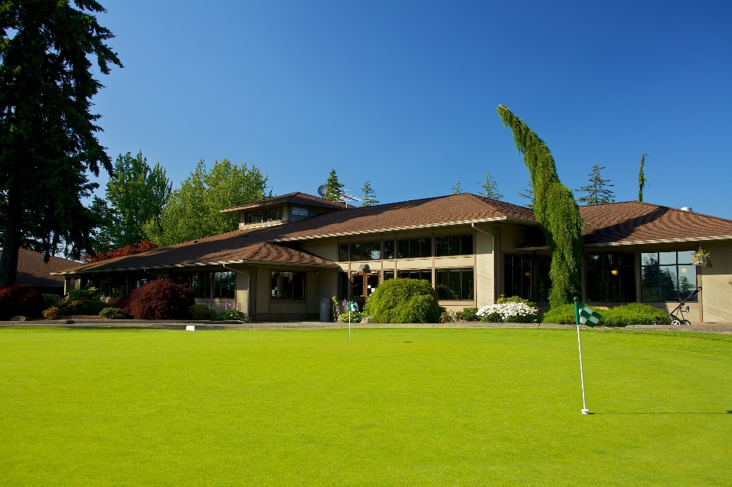

Item 12 Walter Hall Golf Course Restaurant
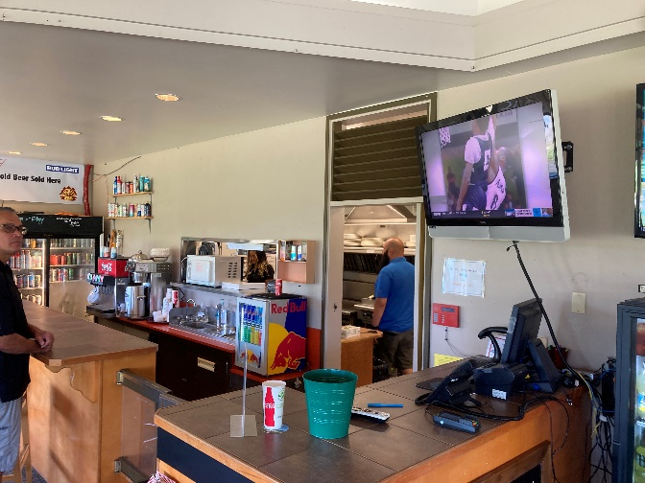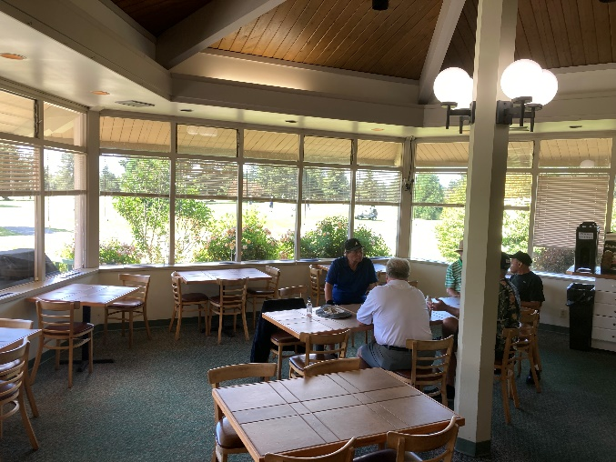
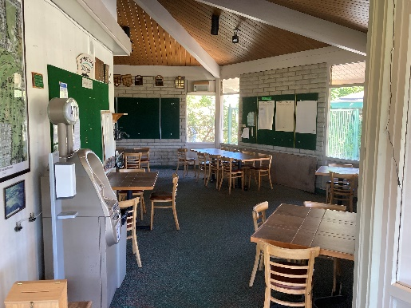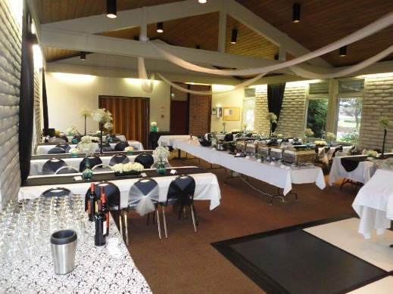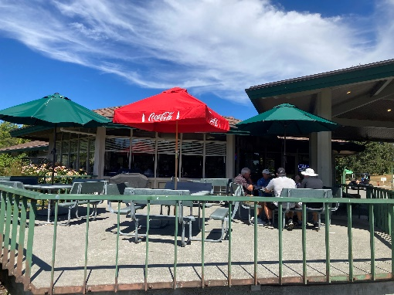
Item 13 Eclipse Mill Park
